Cascadia Masters Rugby Union
Modifications to the Laws of the game for Masters.
2025-26 Season June 8, 2025 Edition

PREAMBLE:
British Columbia Masters Rugby is played according to WORLD RUGBY LAWS of the GAME, variations plus some additional modifications are specific to the CMRU. Canada Rugby has provided a national guideline for Master’s Modifications. BC Rugby has provided the Rules of Competition document which summarizes the structure of the BC Master’s game. This CMRU document, summarises the current variations pertinent to master’s Rugby as it is played in British Columbia. This CMRU document supersedes the Rugby Canada document when issues come into conflict.
Participants must be aged 38 and above and whilst the majority of players are between 38 and 55, there are quite a few in their 60’s and 70’s and some aged 80 and above! As with all aspects of the game, SAFETY is paramount. However, given the wide variation in the ages of players and the equally wide variation in physical prowess it is necessary to introduce some safeguards to ensure the safety of those who either because of previous injury or advancing years would be at risk in the full contact variant of the Game.
It is the responsibility of individual players to determine whether or not they are capable of playing full contact rugby, note however that overly robust play is discouraged at all times in the Masters game.
This document specifically covers the Master’s Modifications and rationale for the current restrictions on tackling players wearing ‘coloured’ shorts and offers refereeing guidelines pertinent to the restrictions on tackling players wearing ‘coloured’ shorts. It also provides the resulting sanctions for any breach of the CMRU modifications. The essential purpose is to ensure consistency, equity and fair play for all.
The Master’s laws created by the “Golden Oldies” and the “World Vintage” organizations are not in play with any Masters game under the jurisdiction of the CMRU.
MASTERS MODIFICATIONS:
SCORING:
A Try shall be the only method of scoring. Kicks at goal after a try shall not be taken. Penalty Kicks at goal shall not count. Drop goal attempts during play shall not count.

SCRUMS:
Scrums are contested, only if all four props are experienced or have been trained as Props. Players of white, black, red, or yellow can willingly participate in a scrum position as a front row or a second row understanding that the scrum will be contested and that they are deemed to be competent. The referee shall determine that both teams meet this requirement. If the criteria for contested scrums cannot be met, then the referee shall declare all scrums to be non-contested. Requesting a non-contested scrum because your forwards are at a tactical disadvantage is not acceptable rationale for requesting a non-contested scrum. In non-contested scrummage situations all forwards must remain bound until the ball has been cleared, scrum halves are not permitted to follow the ball around the scrum. Any purple short player who elects to participate in scrum position as front row or second row changes the status of the scrum to “non-contested.” No push or territorial gain is permitted. An uncontested scrum reduces the risk of injury. The eight man pickup option is not available while scrums remain in the non-contested status. All scrum participants must remain bound until the ball leaves the scrum.
Sanctions: As per world rugby laws, breach of modified laws are: penalty / free kicks.
LINE OUTS:
All lineout laws remain except a quick throw in is not allowed.
Sanctions: The lineout shall be repeated
Regular lineout number limits remain in place. Supporting (lifting) of jumpers is legal.
Sanctions: As per world rugby laws

RUCKS / MAULS:
All mauls shall be played as per World Rugby law with the following exceptions: coloured short ball carriers who are on their feet and initiate direct contact with an opponent may not initiate a maul. Rather, they will be governed by the tackle law. Coloured short ball carriers, once deemed to have been tackled, can make no territorial gain and must play the ball immediately. Conversely, a white or black short ball carrier who is deemed to have been tackled by a coloured short defender and who is in an upright position and who is on their feet, must do the same.
Coloured short players who choose to join onto an existing maul may push for territorial gain and will not change the “contested status” of an established maul.
Coloured short players may choose to join an existing ruck or to initiate a ruck by going to ground while playing the ball immediately playing the ball.
‘Clearing’ out of players not participating in the ruck or maul is not permitted. The principle in this case, is “safety” of the individual, especially when one considers the disparity in physical prowess which will inevitably be present when player ages range from 38 years to over 80 years! Players entering a ruck or maul must temper their contact with regard to the short colour of their opponent and look to bind for the purpose of pushing.
However, the referee may choose to immediately end the ruck or maul should he deem there is an unsafe situation present.
Sanctions: Regular ruck / maul issues as per world rugby laws. All others issues are a penalty kick with or without a yellow or red card. A ruck or maul ended by the referee, due to “safety or stalemate” shall result in a scrum as per World Ruby law.

KICKING:
Players may kick the ball from any place and at any time including: “penalty” kicks/ taps and “free” kicks; kicks for touch; “grubber” kicks; or “pop” kicks not higher than 10 metres. It is the intent of the pop kicker to catch their own kick. “Up and Under” kicks made with the purpose of tackling the ball receiver shall be whistled down immediately. All players must be on side before a “tap penalty” kick is permitted.
Sanctions: Quick kicks are whistled down and are repeated. Illegal kicks in open play shall result in a scrum at the point of infraction for the non-offending team.

RESTARTS:
Following a score, the scoring team shall receive a drop kick from centre as per the World Rugby Laws.
Following a break at quarter time or three-quarter time the game shall resume with a scrum and a put in by the team who last had possession.
Following half-time the game shall resume as per world rugby laws.
Sanctions: As per World Rugby law.
ROLLING SUBSTITUTIONS:
Unlimited substitutions are allowed, and players may return to the field. The emphasis is on participation, however the standard of fitness of players varies considerably and allowing unlimited substitutions ensures participants can play at their own pace! Players can be substituted at normal stoppages. Substitutions during play are only possible with permission of the referee.
Sanctions: Substitution is disallowed until appropriate.
TIME:
Games shall be played over four 15-minute periods, or such lesser time as agreed by both captains and the referee, prior to the start of the game.

CONDUCT:
The referee remains the sole judge of the game and may issue yellow cards, red cards and assign Sin Bin time to any player. Sin Bin time shall be 5 minutes as determined by the referee. A player completing their time in the Sin Bin may only re-enter the game with approval of the Referee / AR at an appropriate stoppage in the game. Any player receiving a red card must be reported to the CMRU and to the BC Rugby’s Discipline Committee by the referee and by both teams involved in the game within 36 hours of the game conclusion.
Sanctions: As per World Rugby law.

VERBAL OUTBURSTS:
Players may not direct comments to the referee or opponents in a derogatory manner. As a gentlemen’s game, this is not acceptable and should be immediately punishable by a penalty kick, a yellow card with sin bin or red cards if deemed necessary.
Sanctions: As per World Rugby law.

UNSPORTING AND DANGEROUS PLAY:
Punching, kicking or dangerous contact around the head is an automatic red card! Some dangerous play, not involving contact around the head, can be mitigated, and can be penalized with a yellow card with sin bin if deemed appropriate. The days of sorting things out are gone! All players must act and play within the Laws. The referee’s authority is without question.
Sanctions: As per World Rugby law.

SPIRIT OF THE GAME:
If a team “repeatedly” uses intentional and unreasonable tactics to take advantage of, or make use of, Yellow, Red, or Purple short players. The referee shall be the judge of “repeated” actions and to fairness, with regard to, the ‘spirit of the game”. If the referee rules that such tactics are reasonable and are not repeated and do not present a question of fairness, then play shall continue. The Masters game modifications are based on fairness and consideration in blending various abilities in a competitive setting.
Sanction: A scrum for the team in possession of the ball at the time of violation.

RESTRICTIONS INVOLVING COLOURED SHORTS:
All players must observe the restrictions on contact with players wearing coloured shorts i.e. black, red, gold or purple. The rationale for the restriction is for reasons of safety.
Sanctions: Infractions involving illegal contact may be punishable as an automatic yellow card with sin bin or a red card if deemed dangerous, particularly to the neck or to the head. Based on the situation, the referee may choose to mitigate the severity of the infraction resulting in a penalty kick.

TACKLE:
World Rugby tackle law is the foundation of the modifications. These laws are applicable for tacklers or those receiving a tackle when the contact involves only White or Black short players. However, the criteria for a tackle and the subsequent “release requirement” varies if the tackler or the person receiving the tackle has a short colour of Red, Yellow or Purple. Once the ball carrier is “deemed to have been tackled” as per the colour shorts involved, they must immediately (1-2 seconds) release the ball, or play it, by passing it, by posting it or by slipping the ball to a team mate. A Red, Yellow, or Purple short player is not required to go to ground after being tackled, but may choose to do so. The referee should yell “tackle, release” to indicate a tackle has taken place. If the tackle involves, red, and yellow players the tackler must remain onside and in close proximity (one metre) to the ball carrier until the ball has been played by the ball carrier. Once the tackler has released the ball carrier and the ball carrier has released the ball, the requirements for the tackle law have been met.
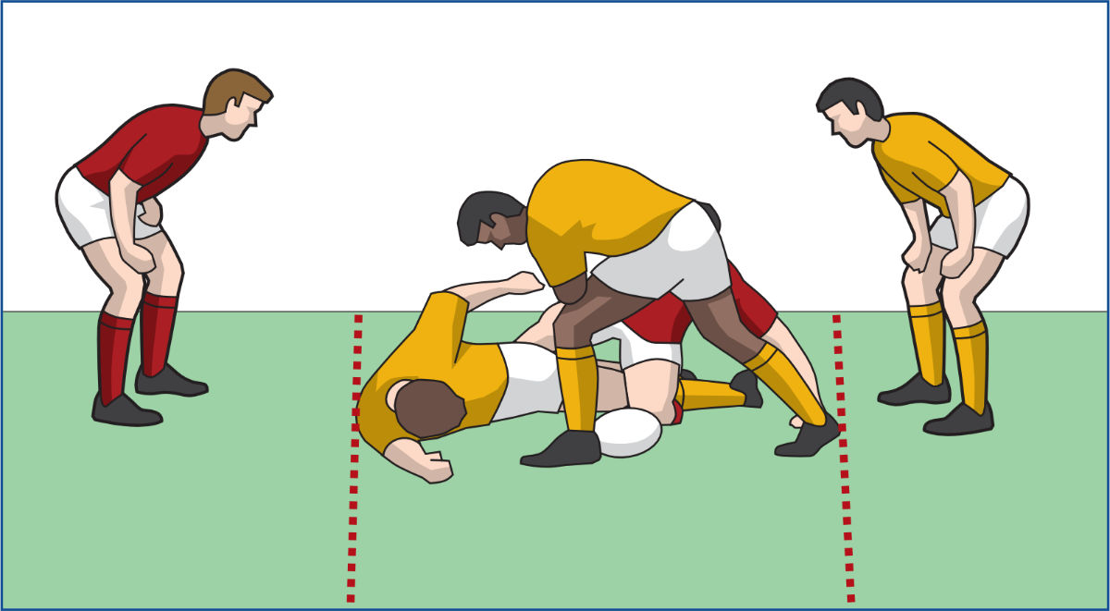
Sanctions: As per World Rugby law.

OTHER VARIATIONS:
COLOURED SHORTS – GUIDELINES:
WHITE SHORTS (Age range: min. 38 - max. 49) Players who wear white shorts must clearly understand the restrictions placed upon them with regard to defending opponents wearing any coloured shorts. There are no restriction on tackling a white short ball carrier. White short ball carriers must temper their contact with regard to coloured short defenders especially with regard to fending off tacklers.
Sanctions: Penalty kick at the point of infraction with or without a yellow or red card for actions against coloured short players.
BLACK SHORTS (Age range: min. 50 - plus) Players who wear black shorts must clearly understand the restrictions placed upon them with regard to defending opponents wearing Red, Gold or Purple coloured shorts. Players tackling a Black short ball carrier must “temper” the contact. Excessive intensity during contact, with the possibility or intent to injure, is dangerous play! However, Black short ball carriers should expect to be tackled.
Sanctions: Penalty kick at the point of infraction with or without a yellow or red card for actions against coloured short players.

RED SHORTS (Men’s Age range: min. 60 – plus / Women’s Age range: min: 38 - plus) Any player wearing red shorts is not to be conventionally tackled but may be “wrapped” and held. The red short ball carrier once “wrapped” and held, must immediately release, or pass or post the ball with an attempt to form a ruck or a maul. If a defending player can place and “grip or hold” both his hands on the body of the red short ball carrier, anywhere on the torso from the line of the shoulders to the waist, then the red short ball carrier is deemed to be ‘tackled’ and must not advance and must then play the ball. Similarly, if two defending players manage to place and “grip or hold” one hand each simultaneously upon the torso of the red short ball carrier then he is deemed to be tackled and must stop and immediately play the ball. Once the defending players have “wrapped” the red short ball carrier, they may not then strip the ball from him or wrap him in such a way that he is unable to play the ball once deemed “tackled”. The red short ball carrier once “wrapped” must not attempt to advance and gain territory. A red shorts defender should never be charged down by an offensive ball carrier. Dropping a shoulder, fending the head or body or even hard contact against a red short player by a white, or black short attacker is deemed dangerous play. A red shorts defender who “wraps” a player of white or black shorts is deemed to have tackled that player. Any player who has been tackled must immediately release the ball, or play it, by passing it, by posting it or by slipping the ball to a team mate to form a maul.
Sanctions: Penalty kick at the point of infraction with or without a yellow or red card for actions against coloured short players.
GOLD SHORTS (Age range: min. 70 - plus) – Any player wearing gold shorts is not to be tackled, wrapped or held but they may be “two open hand touched”. Similarly, if two defending players manage to place one hand each simultaneously upon the torso of the gold short ball carrier then he is deemed to be tackled and must stop and immediately release, pass or drop the ball. Once the defending players have “touched” the gold short ball carrier, they may not then strip the ball from him. The gold short ball carrier once “touched” must not attempt to advance and gain territory. A gold short player who is carrying the ball must not be brought to the ground. A gold shorts defender should never be charged down by an offensive ball carrier. Dropping a shoulder, fending the head or body or even hard contact against a gold short player by a white, black, or red short attacker is deemed dangerous play. A gold shorts defender who “two hand touches” a player of white, black or of red shorts is deemed to have tackled that player. Any player who has been tackled must immediately release the ball, or play it, by passing it, by posting it, or by slipping the ball to a team mate to form a maul.
Sanctions: Penalty kick at the point of infraction with or without a yellow or red card for actions against coloured short players.
PURPLE SHORTS (Age range: 80 - plus) – Any player wearing purple shorts is not be impeded in any way and is afforded unlimited freedom of action. Purple short ball carriers may not be touched, held, wrapped or tackled by the defence. Purple short ball carriers can only advance the ball 10 metres and then they must pass, play, or release the ball. Purple short ball carriers may score a try but may not carry the ball across the opponent’s goal line and score. A purple shorts defender should never be charged down by an offensive ball carrier. Dropping a shoulder, fending the head or body or even hard contact against a purple short player by a white, black, red or gold short attacker is deemed dangerous play. A purple shorts defender who “one open hand touches” a player of white, black, red, or of gold shorts is deemed to have tackled that player. Any player who has been tackled must immediately release the ball, or play it, by passing it, by posting it, or by slipping the ball to a team mate to form a maul.
Sanctions: Penalty kick at the point of infraction with or without a yellow or red card for actions against coloured short players. Scrums shall be awarded to the non offending team if a Purple short player advances beyond restricted their limits.

FOOTNOTE: To a certain degree, Masters rugby remains a skilled, running, kicking game with contact. Players must have mobility to play both offence and defence! Should special temporary circumstances arise that "special" rules must be put in place, the modifications still allow for this during the pre-game referees meeting!

AGE EXCEPTIONS FOR COLOURED SHORTS:
- Players may petition, to play using an older short colour due to a, legitimate impairment or injury at the beginning of each game. With the pre-game permission of both captains and the referee, this would involve playing at a short level older than their true age. Such a decision will be determined on a game by game basis. This player, if approved, must be wearing the “appropriate and approved” coloured shorts and he must conform to the guidelines and spirit applicable to the short level.
- Female players may choose to play, wearing a short colour recognizing their applicable age or elect to play at the Red short level regardless of their age. This can be done without a pre-game petition.
- Players and clubs should not take advantage of this provision and should petition as an exception.
- Consideration should be given pre-game to the number of “special exception” players on the pitch at one time.
- In most cases, players who petition for “special exception” will be doing so as a temporary measure.

COLOURED HEAD GEAR / SCRUM CAPS – GUIDELINES:
All players wearing coloured scrum caps are strongly encouraged to wear only matching head gear colours to their short colour. Approved headgear comes in white, black, red, yellow and purple. In particular, Red, Yellow and Purple shorts with matching colour head gear increase these players visibility and therefore offer better protection for correct tackling procedure. Conversely players wearing non matching head gear or “other” colours may confuse opponents, and is not ideal.

The aim of these guidelines is to assist everyone involved in Masters Rugby to play and manage the game for the benefit of all. The essential purpose is to ensure SAFETY and EQUITY for every player who participates or wishes to participate in British Columbia Masters Rugby irrespective of physical capability, sex, or age.

CMRU Law Modification Committee: Dave Irving / Bill Lang / Glen Okraninetz.

